**Project GUI and Software Design**

🟡 I’d like to introduce the camera view of ***BRAVEHEART***.

🟣 On each layer of this dungeon, several rooms are generated randomly on space, and adjacent rooms are connected through paths. When a player is inside one room, he can see this room only, with limited perspective (see the red rectangular below in Fig.1).

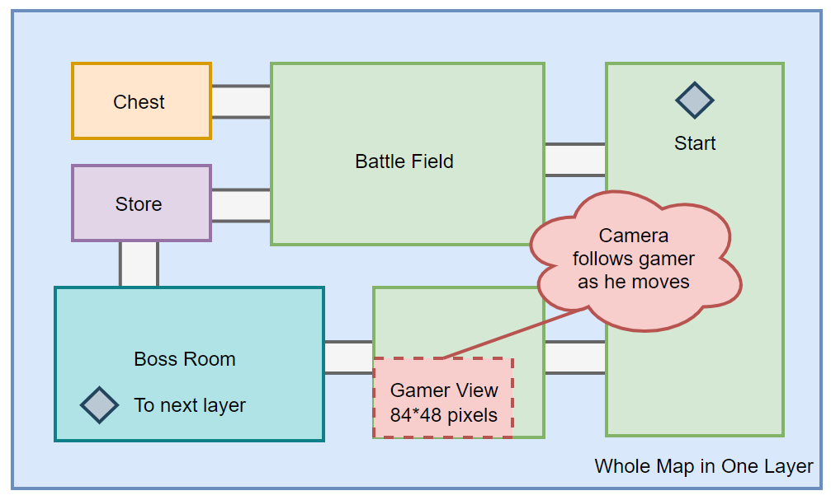

Fig.1 General map illustration

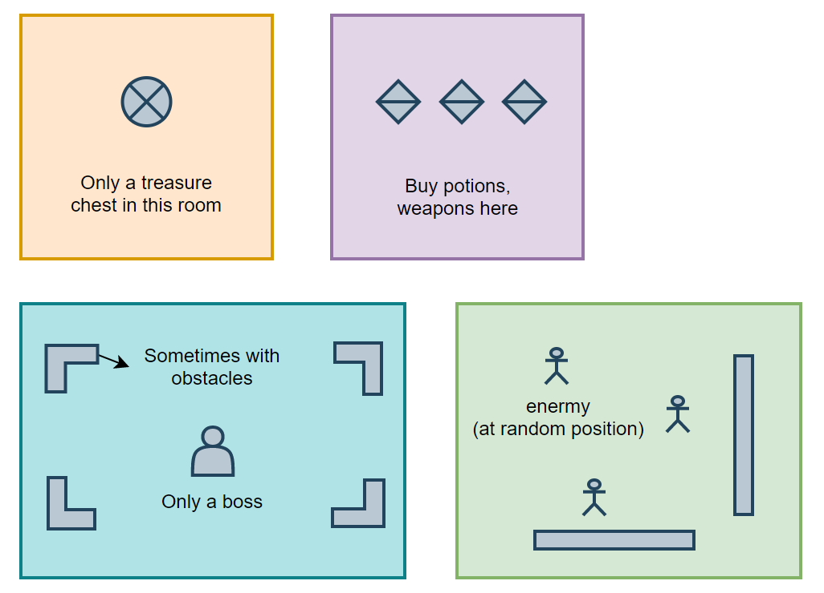



Fig.2 Room functions

🟤 The 2D textiles are still being designed (I am testing if I can apply techniques to display 2-bit sprites, e.g. through simulated software-based-PWM to create different levels of gray), but I can show you some of them on 1-bit image (Fig.3 to Fig.5).

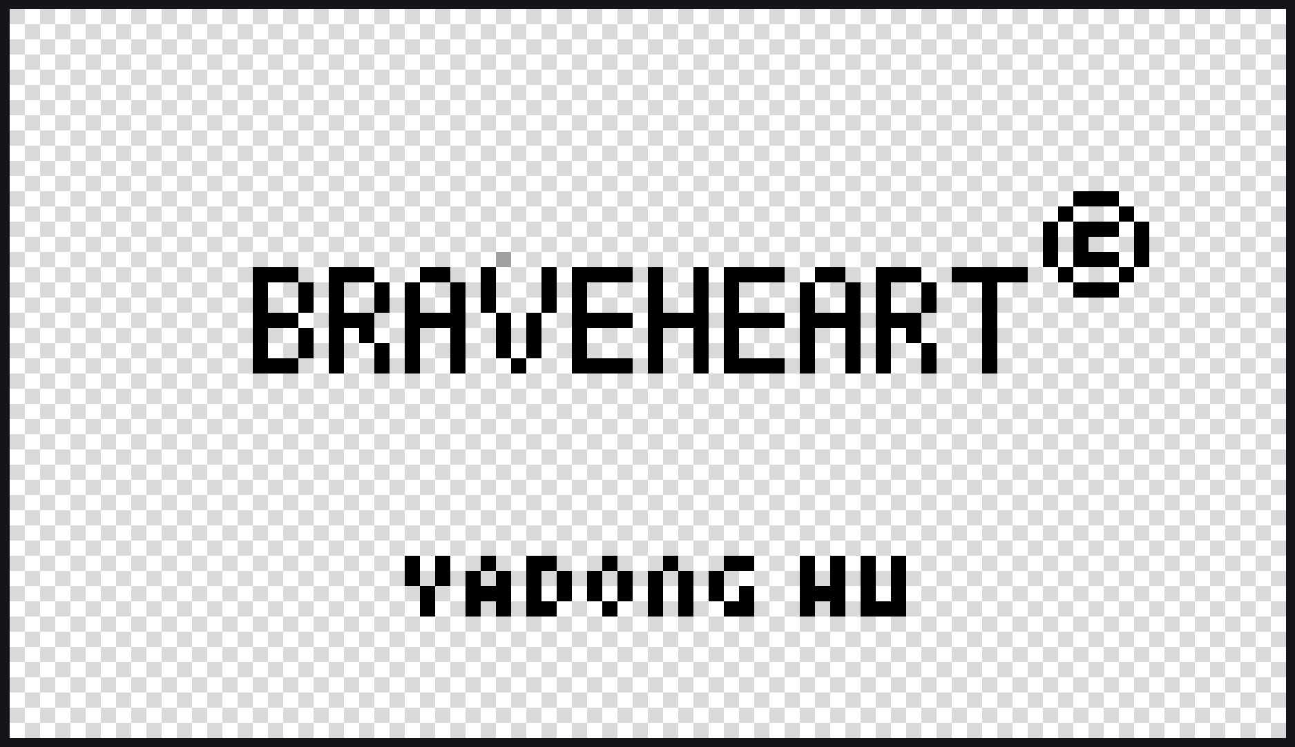

Fig.3 Welcome page

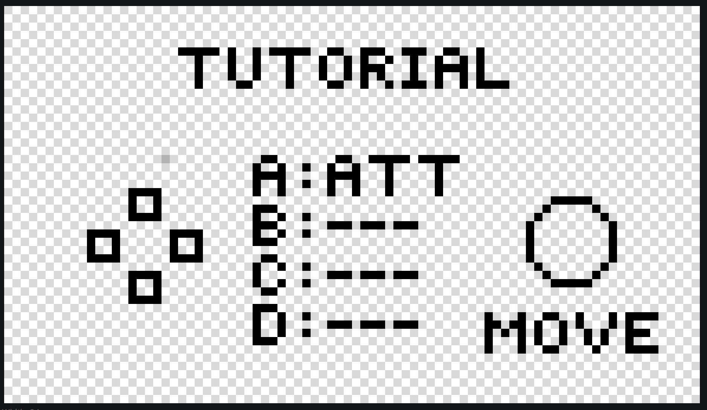

Fig.4 Tutorial page

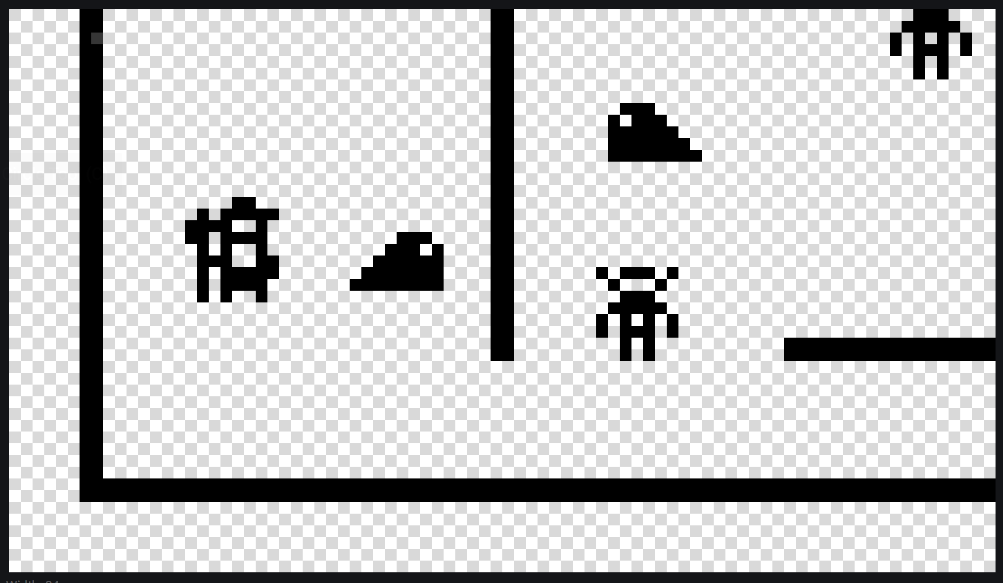

Fig.5 Battle example

🔵 Finally, these are classes needed and their relevant functions (Fig.6):

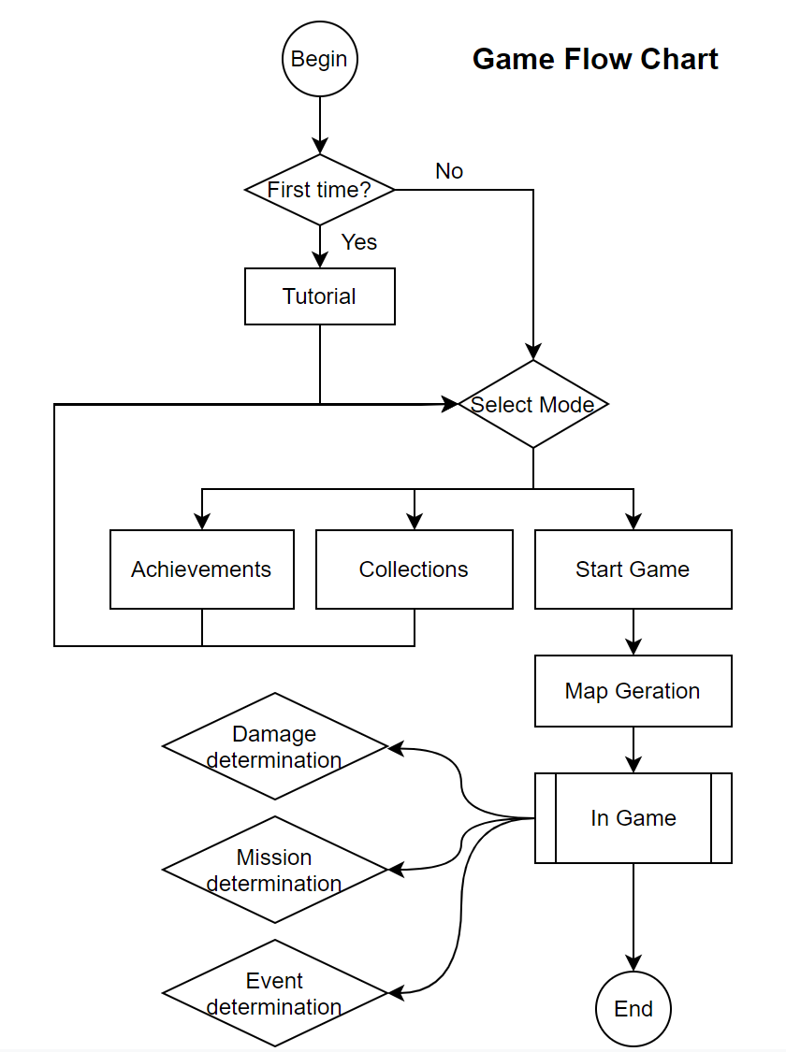

Fig.6 Game flow chart, each indicates the class needed